**Apache Tomcat Configuration Latest (9.0.85)**

**Components of Tomcat:**

1. **Catalina**: It is the Servlet Container of Tomcat.
2. **Coyote**: Coyote acts as a connector and supports HTTP 1.1
3. **Jasper**: It is the Tomcat’s JSP Engine.
4. **Cluster**: A component for load balancing to manage large applications.
5. **High availability**: A Tomcat component to schedule system upgrades and changes without affecting live environment.
6. **Web Application**: Manage Sessions, Support deployment across different environments.

**Login as Root user:**

1. Install Latest Java.
2. Download the Apache tomcat.

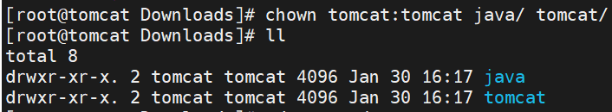

**Unzip tomcat file:**





**Check for tomcat code: (for validation purpose)**



**Change access to files:**





**Create Group:** groupadd tomcat



**Add User:** useradd -s /bin/false -g tomcat -d /opt/tomcat tomcat



**Change ownership:** chown -R tomcat:tomcat /opt/tomcat/



************************************************************************

**(Optional step)**

**Link Startup command:**

ln -s /u01/softwares/tomcat/apache-tomcat-6.0.1/bin/startup.sh /usr/bin/tomcatup

**Link Shutdown command:**

ln -s /u01/softwares/tomcat/apache-tomcat-6.0.1/bin/shutdown.sh /usr/bin/tomcatdown

**\*\*\*\*\*\*\*\*\*\*\*\*\*\*\*\*\*\*\*\*\*\*\*\*\*\*\*\*\*\*\*\*\*\*\*\*\*\*\*\*\*\*\*\*\*\*\*\*\*\*\*\*\*\*\*\*\*\*\*\*\*\*\*\*\*\*\*\*\*\*\*\***

**Access Server:**

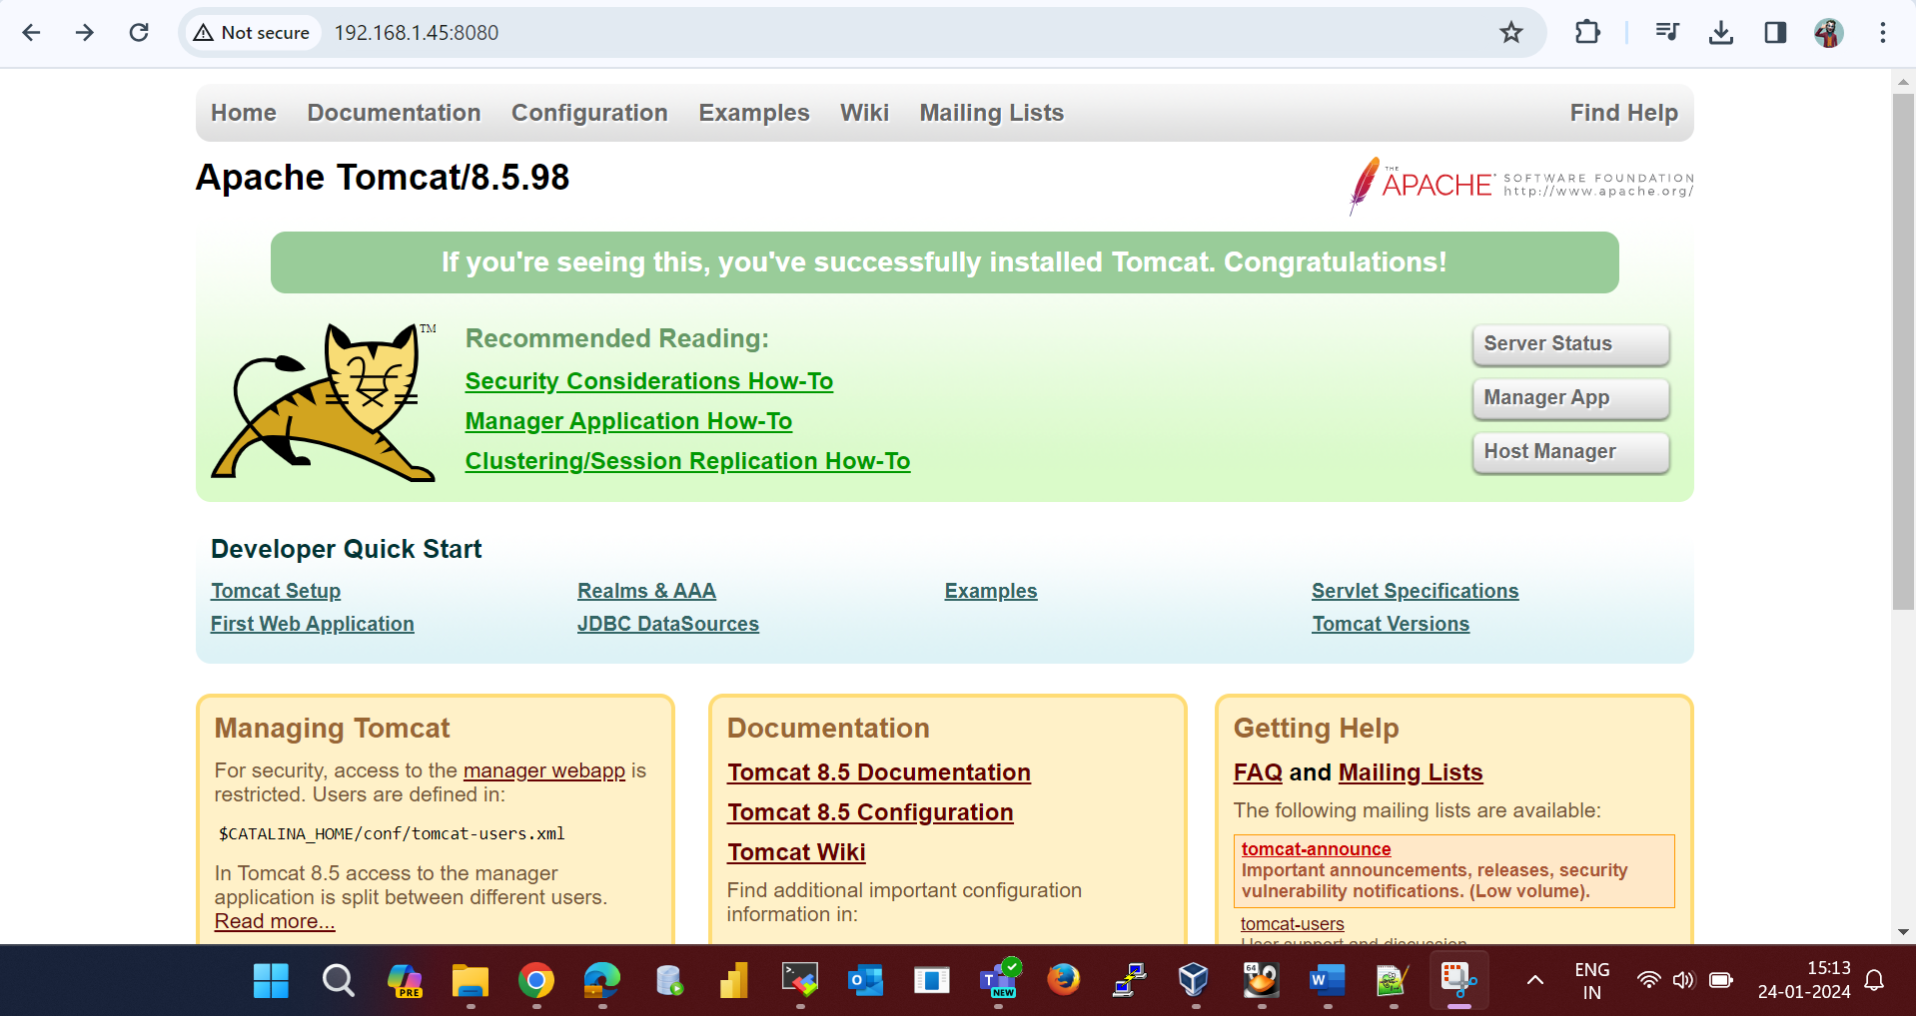

**To check running port:** netstat -tunlp (or) ss -plnt

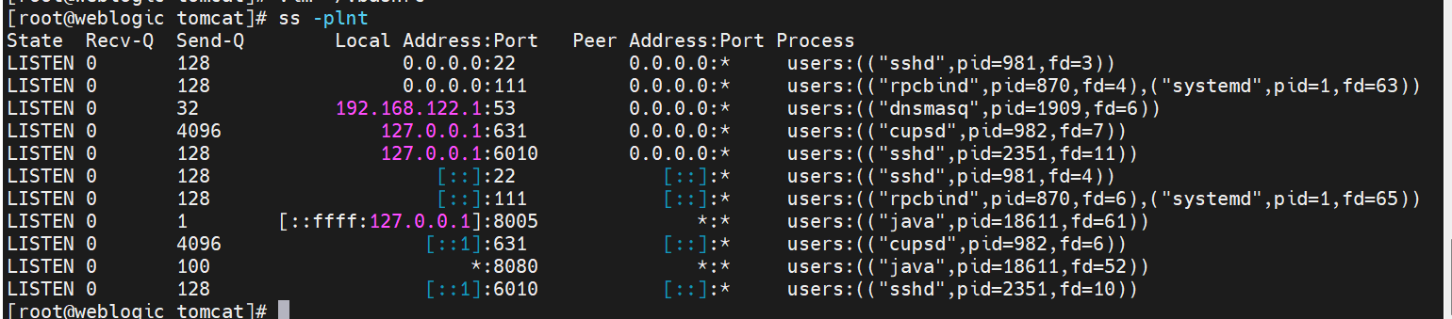

**Set Environment Paths:**

export JAVA_HOME=”/home/tomcat/Downloads/java/jdk11.0_21”

CATALINA_HOME= /home/tomcat/Downloads/tomcat/apache-tomcat-9.0.85

CATALINA_BASE= /home/tomcat/Downloads/tomcat/apache-tomcat-9.0.85

**Add Roles in below path:**  **tomcat-users.xml**

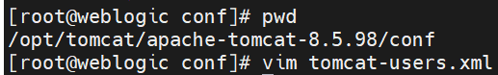

<role rolename="tomcat"/>

<role rolename="manager-gui"/>

<role rolename="admin-gui"/>

<user username="tomcat" password="tomcat" roles="tomcat,manager-gui,admin-gui"/>

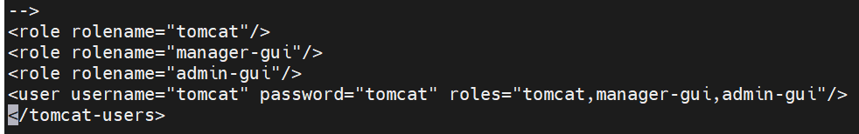

**Goto Below path: Disable Catalina className**

/opt/tomcat/apache-tomcat-8.5.98/webapps/manager/META-INF

vim context.xml



**Goto Below path:**

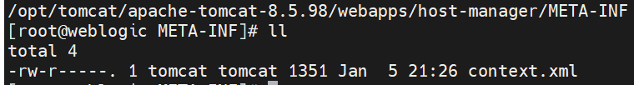

vim context.xml



Restart Services

**********************************************************************

1. **Check Firewalld status:**

systemctl status firewalld.service

1. **Stop Firewalld for the current session:**

systemctl stop firewalld.service

1. **Confirm Firewalld is inactive:**

systemctl status firewalld

***********************************************************************

**Server Status Check:**

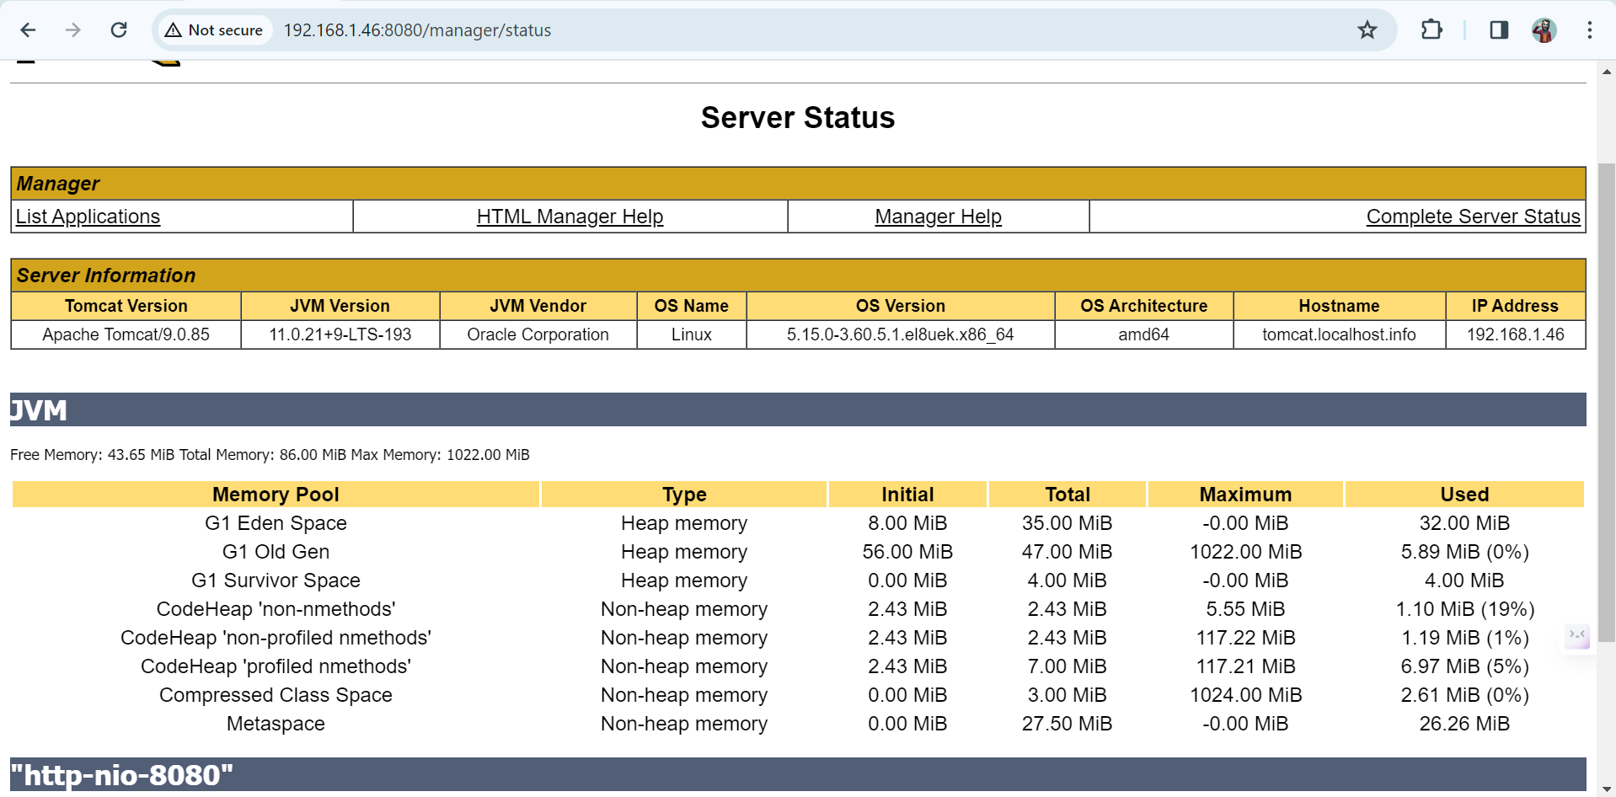

**Application Manager:**

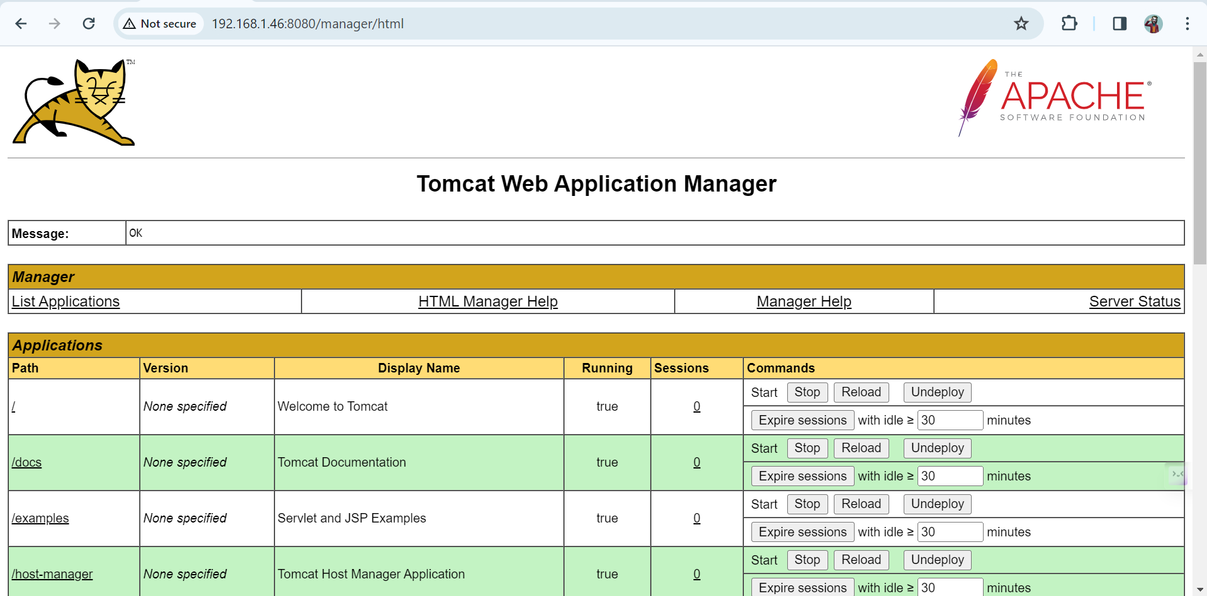

**Host-Manager:**

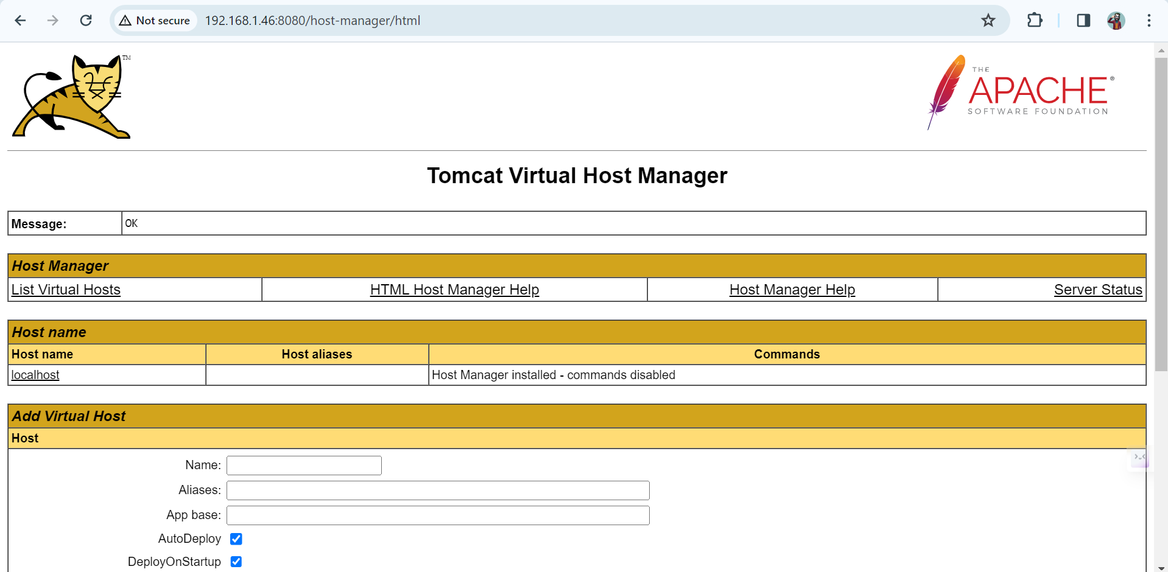

***************************************************************************

**Application Deployment:** Choose the path for jar/war file.

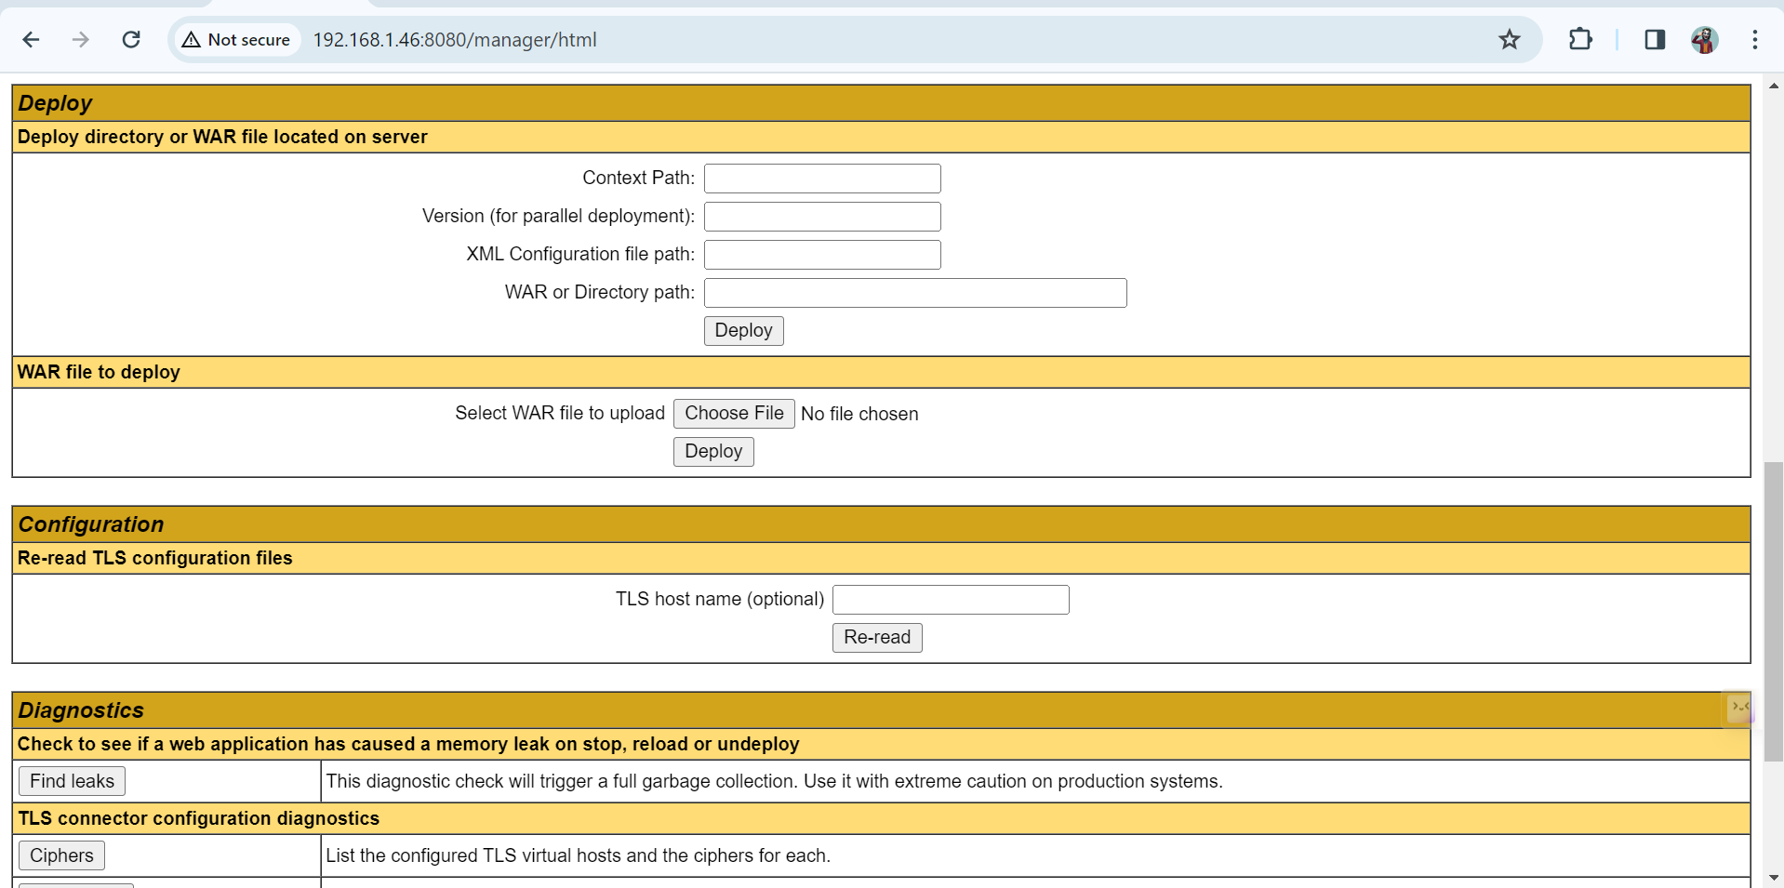

**Deployed Sample Application:**

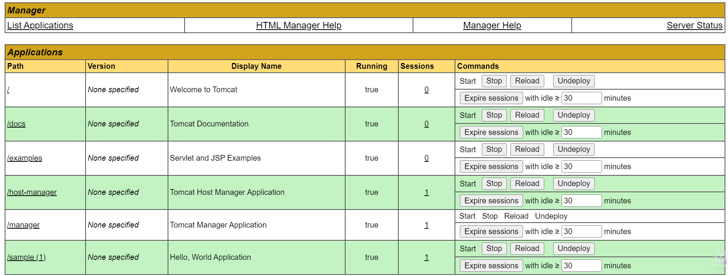

**Output for Deployed Application:**

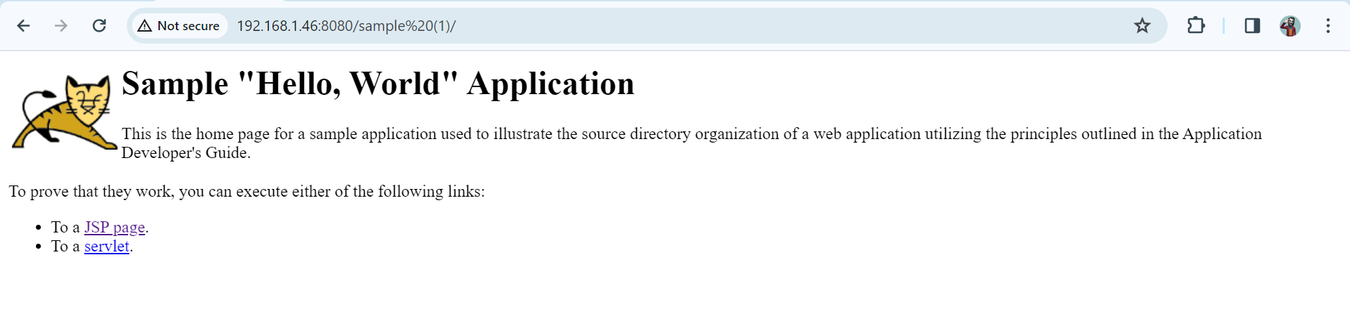

**Successfully deployed application.**

**\*\*\*\*\*\*\*\*\*\*\*\*\*\*\*\*\*\*\*\*\*\*\*\*\*\*\*\*\*\*\*\*\*\*\*\*\*\*\*\*\*\*\*\*\*\*\*\*\*\*\*\*\*\*\*\*\*\*\*\*\*\*\*\*\*\*\*\***

To enable the Manager App for remote access, edit the following context.xml file:

nano /opt/apache-tomcat-9.0.65/webapps/manager/META-INF/context.xml

Copy

Remove the following lines:

<Valve className="org.apache.catalina.valves.RemoteAddrValve"

allow="127\.\d+\.\d+\.\d+|::1|0:0:0:0:0:0:0:1" />

Copy

To enable the Host Manager App for remote access, edit the following context.xml file:

nano /opt/apache-tomcat-9.0.65/webapps/host-manager/META-INF/context.xml

Copy

Remove the following lines:

<Valve className="org.apache.catalina.valves.RemoteAddrValve"

allow="127\.\d+\.\d+\.\d+|::1|0:0:0:0:0:0:0:1" />

Copy

Save and close the file when you finish.